Setup for R in Windows 10

# Preparation

If you have any previous version of R installed, it should be uninstalled and all directories cleared. Please follow the steps described here:

<https://stackoverflow.com/questions/55204017/how-to-uninstall-r-and-rstudio-with-all-packages-settings-and-everything-else>

# Installation

## R

Download R 4.0.x

Install the 64-bit files (uncheck 32 bit during installation, unless you are sure you need them) as administrator to C:\Program Files\R

## RTools

Download RTools40 from <https://cran.r-project.org/bin/windows/Rtools/>

Install to C:\rtools40 as administrator

## RStudio

Download RStudio from <https://rstudio.com/products/rstudio/download/#download>

Install to C:\Program Files\RStudio

# Setup R environment and build tools

Open RStudio as normal user and verify library

.libPaths()

"C:/Program Files/R/R-4.0.3/library"

* We make this path writable for *User* (“*Benutzer*”), such that we can install new packages there
* It is recommended to only have one library.

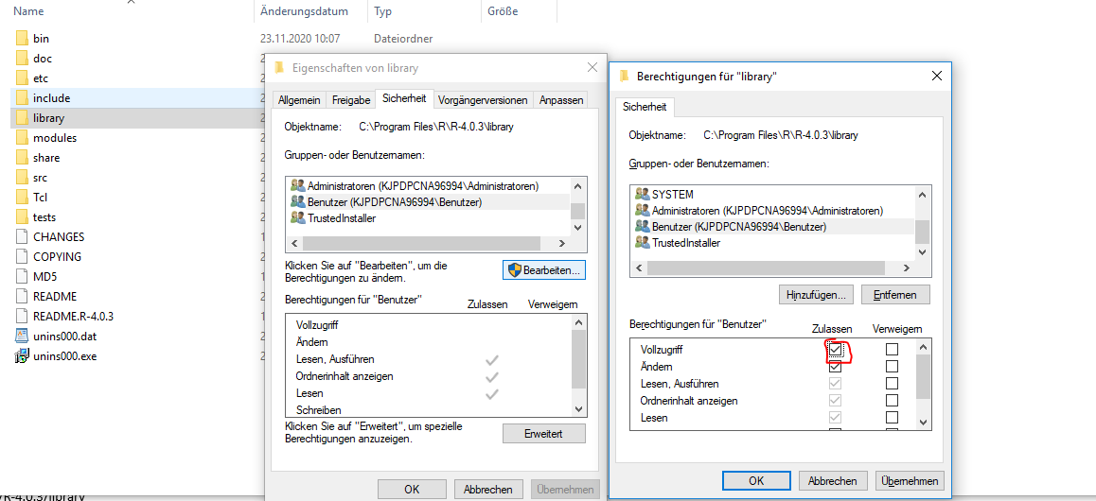

Open System settings as administrator to verify that **RTools** are in the *path*

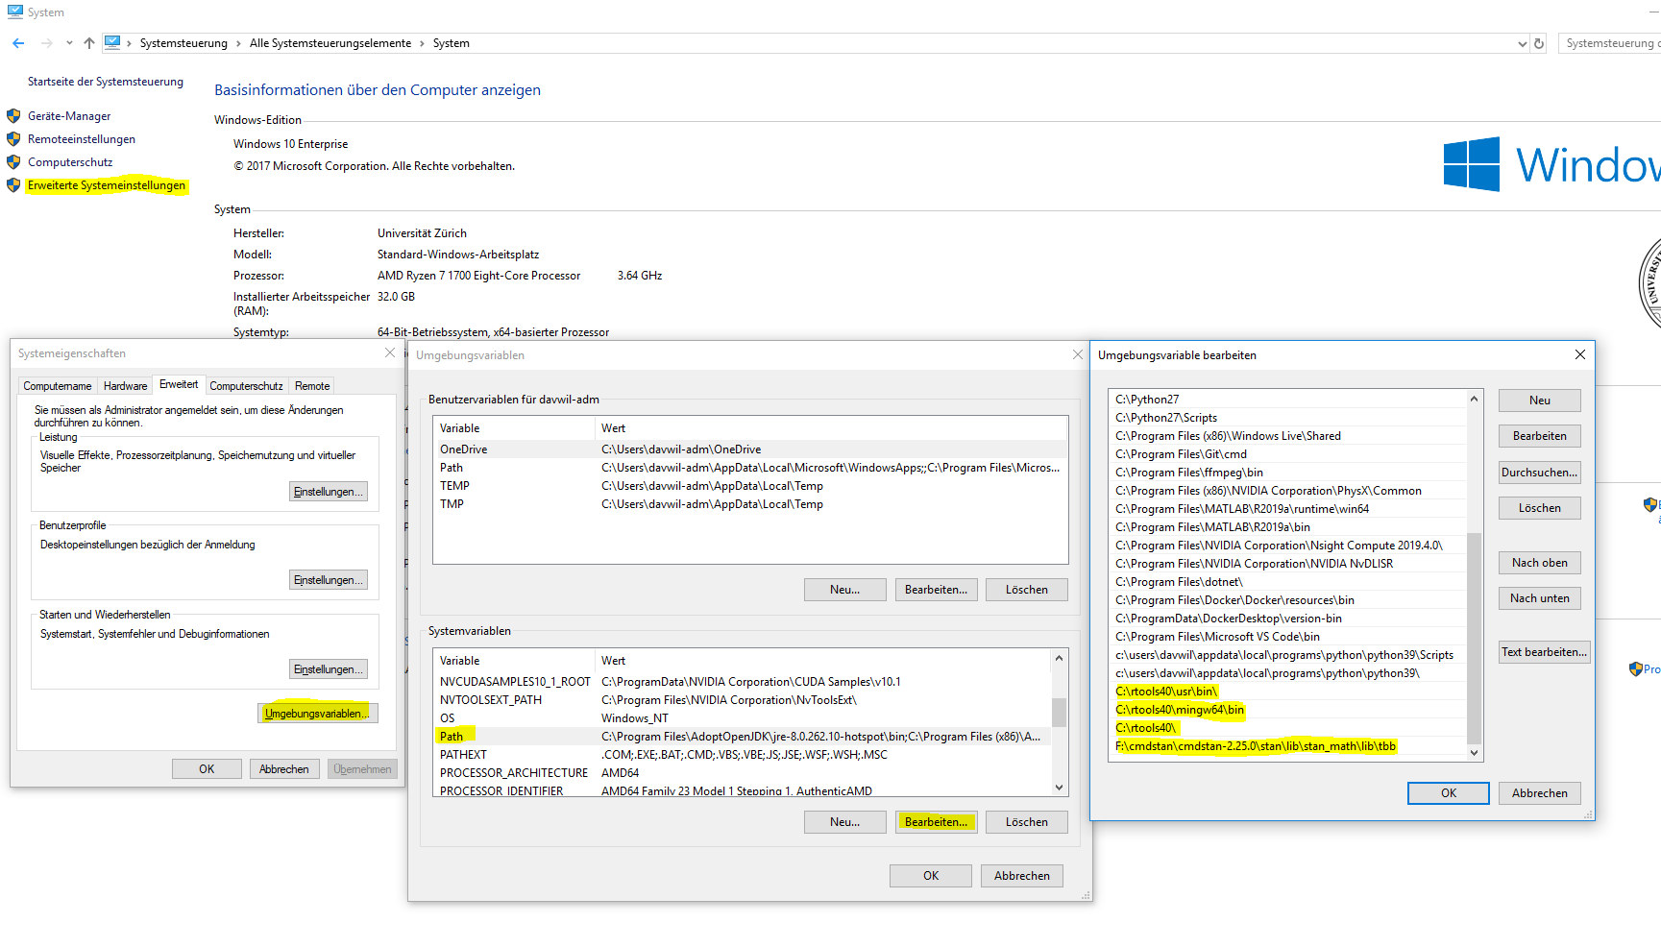

**Install mingw32-make**

Open ***RTools bash*** and type

pacman -Syu mingw-w64-x86_64-make

to synchronize databases and restart RStudio.

To verify the correct installation of make run the following in RStudio:

system("where mingw32-make")

The output should look like this:

C:\rtools40\mingw64\bin\mingw32-make.exe

Verify environment variables

Sys.getenv()

R_LIBS_USER

RTOOLS40_HOME

Verify PATH variable contains:

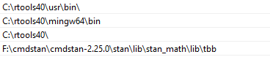

# Setup Stan in R

## Set up cmdstan and cmdstanr

### cmdstan

dir.create("F:/cmdstan/") # choose a local directory with write permissions

Download the current version of cmdstan to this directory and unpack it such that the files are now in e.g. F:/cmdstan/cmdstan-2.25.0/ and cd() into this dir in cmd.exe

<https://github.com/stan-dev/cmdstan/releases/download/v2.25.0/cmdstan-2.25.0.tar.gz>

**Install tbb**

In cmd.exe

F:

cd F:/cmdstan/cmdstan-2.25.0/

mingw32-make install-tbb

Add / verify that

F:\cmdstan\cmdstan-2.25.0\stan\lib\stan_math\lib\tbb

is in the to the *PATH* now! It should now look like this:



Then restart cmd.exe to update PATH and cd again to cmdstan-2.25.0 and run

F:

cd F:/cmdstan/cmdstan-2.25.0/

mingw32-make build

Installation of cmdstan should now be complete.

### cmdstanr

Go to RStudio and call

[install.packages](https://rdrr.io/r/utils/install.packages.html)("cmdstanr", repos = [c](https://rdrr.io/r/base/c.html)("https://mc-stan.org/r-packages/", [getOption](https://rdrr.io/r/base/options.html)("repos")))

library(cmdstanr)

set_cmdstan_path("F:/cmdstan/cmdstan-2.25.0")

mod <- cmdstan_model("F:/cmdstan/cmdstan-2.25.0/examples/bernoulli/bernoulli.stan")

If you can compile the example model, everything worked out ☺

## Setup rstan

[install.packages](https://rdrr.io/r/utils/install.packages.html)(c("StanHeader","rstan"))

# Troubleshooting

**Error: “g++ not found during compilation of model”**

Warnmeldung:

In system(paste(CXX, ARGS), ignore.stdout = TRUE, ignore.stderr = TRUE) :

'C:/Rtools/mingw_/bin/g++' not found

> Sys.getenv("WIN")

> Sys.setenv(WIN = "64")

**Error: “Mingw32-make not found”**

Open *RTools bash* and type

pacman -Syu mingw-w64-x86_64-make

to synchronize databases and restart RStudio or cmd.exe

**Error: “C:/rtools40/mingw64/bin/../lib/gcc/x86_64-w64-mingw32/8.3.0/../../../../x86_64-w64-mingw32/bin/ld.exe: skipping incompatible C:/rtools40/mingw64/bin/../lib/gcc/x86_64-w64-mingw32/8.3.0/../../../../x86_64-w64-mingw32/lib/libpsapi.a when searching for –lpsapi”**

Check if there are any conflicts in the path, e.g. does

where ld.exe

in cmd.exe give you more than one result? 🡪 Adjust the PATH then such that the RTools-executables are used.

**“I added XYZ to the PATH but R does not find the executable”**

Make sure that every time you change the PATH, you need to restart currently running cmd.exe / RStudio instances to see the effect.